Unity Catalog

What is databricks?
Databricks is a cloud-based data platform designed to help organizations unify their data engineering, data science, machine learning, and analytics workflows—all in one collaborative environment.
It’s built on Apache Spark and offers powerful tools for processing large-scale data efficiently.

Explain Azure Databricks Architecture?
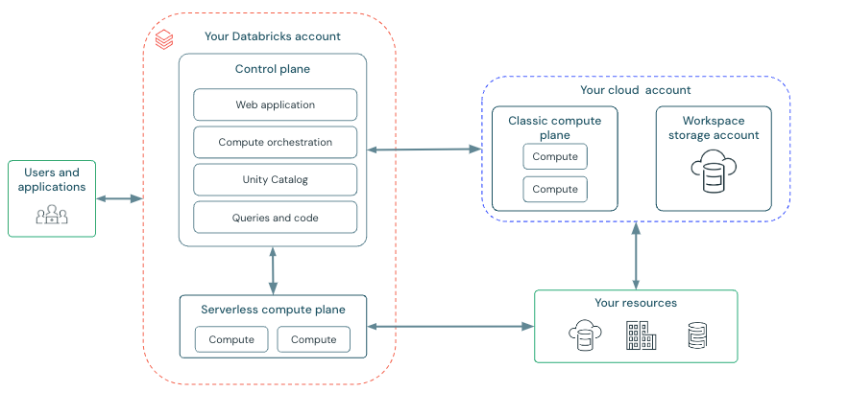

Azure Databricks operates out of a control plane and a compute plane.
- The control plane includes the backend services that Azure Databricks manages in your Azure Databricks account. The web application is in the control plane.
- The compute plane is where your data is processed. There are two types of compute planes depending on the compute that you are using.
  - For serverless compute, the serverless compute resources run in a serverless compute plane in your Azure Databricks account.
  - For classic Azure Databricks compute, the compute resources are in your Azure subscription in what is called the classic compute plane. This refers to the network in your Azure subscription and its resources.

When you create a workspace, Azure Databricks creates a account in your Azure subscription to use as the workspace storage account.
The workspace storage account contains:
- Workspace system data: Workspace system data is generated as you use various Azure Databricks features such as creating notebooks. This bucket includes notebook revisions, job run details, command results, and Spark logs
- DBFS: DBFS (Databricks File System) is a distributed file system in Azure Databricks environments accessible under the dbfs:/ namespace. DBFS root and DBFS mounts are both in the dbfs:/ namespace. Storing and accessing data using DBFS root or DBFS mounts is a deprecated pattern and not recommended by Databricks. For more information, see What is DBFS?.
- Unity Catalog workspace catalog: If your workspace was enabled for Unity Catalog automatically, the workspace storage account contains the default workspace catalog. All users in your workspace can create assets in the default schema in this catalog.

Create Resource Group:

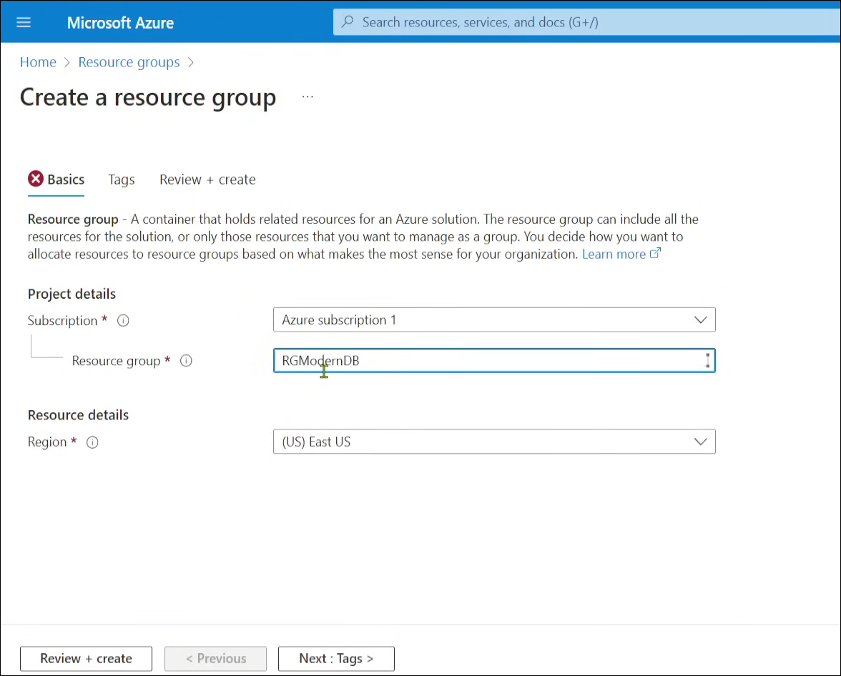

Create Storage Account:

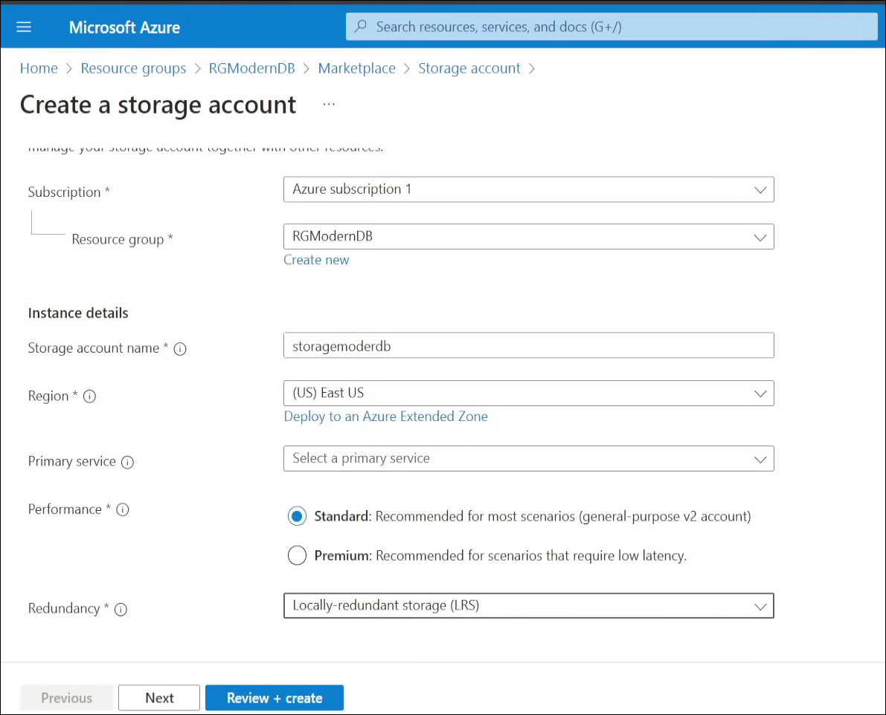
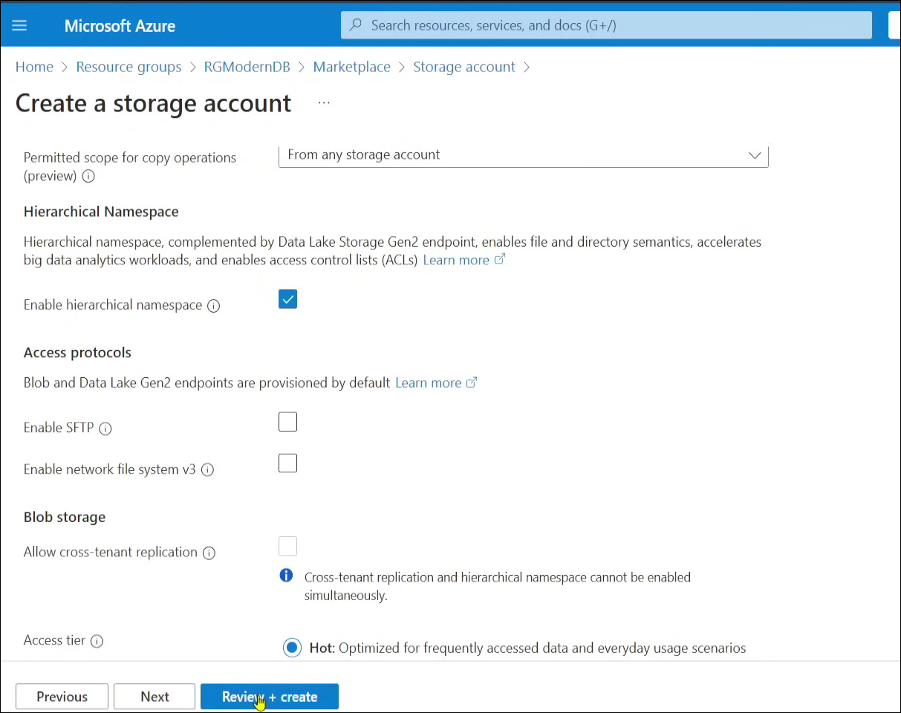

Click Review + Create

Create Azure Databricks Workspace:

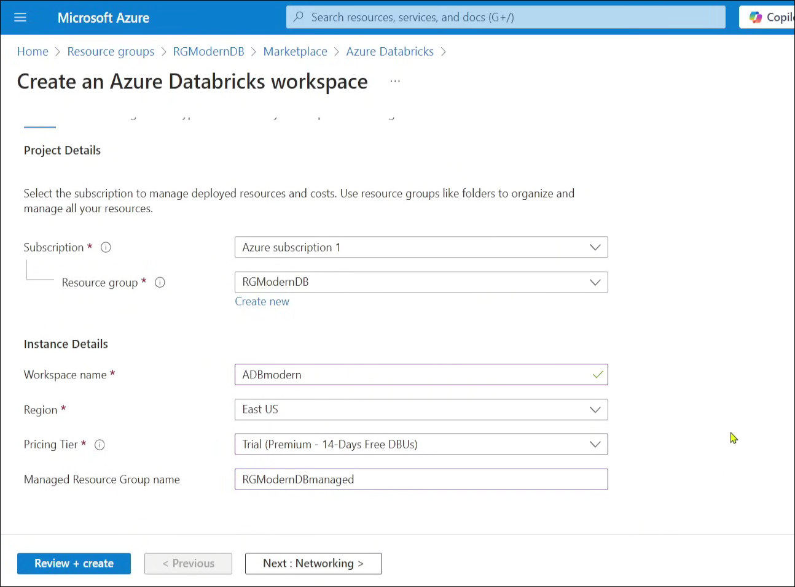

Click Review + Create

Unity Catalog Definition:

What is Unity Catalog?
Unity Catalog is a central system to manage and govern all your data in Azure Databricks.
Think of it like a "library catalog" for your data — it tells you:
- What data you have
- Who can access it
- Where it lives
- What’s been done to it

Unity Catalog Manages:
Layer | Example

Metastore | The top-level container (like a whole database system)

Catalog | Like a folder (e.g., main, sales, finance)

Schema | Like a sub-folder (e.g., raw, cleaned, reports)

Table/View | Actual data tables and views (e.g., customers, orders)

What is a Metastore?
A metastore is like a master directory that keeps track of all your data, who can access it, and where it lives. It’s required for using Unity Catalog in your workspace.

How is Data Organized in the Metastore?
Unity Catalog uses a 3-level hierarchy to organize your data:

Level 1: Catalog
A catalog is like a main folder or top-level category. Used to group data by department, environment (e.g., dev, test, prod), or business unit. Example finance, marketing or Prodcatalog

Level 2: Schema (aka Database)
A schema is like a sub-folder inside a catalog. Organizes data for a specific project, team, or use case. Example : customer_data, sales_analysis

Level 3: Objects (Data & AI assets)
Inside each schema, you can store different types of data and AI assets:
Object | Description
Tables | Structured data (rows and columns). Can be managed or external.
Views | Saved SQL queries that show data from tables (like virtual tables).
Volumes | Unstructured files like JSON, CSV, logs, images, etc., in object storage.
Functions | Reusable logic (like UDFs) for calculations or custom operations.
Models | Machine learning models tracked via MLflow, used like functions.

Managed vs External: Simple View
Type | Managed | External
Table/Volume | Databricks controls storage + metadata | Databricks controls only metadata
Use case | Simple ETL, tight governance | Accessing existing files in ADLS/S3

Summary
- Metastore = Main registry of all data.
- Catalog = Top-level group (e.g., department or environment).
- Schema = Folder inside catalog (project or team-specific).
- Objects = Tables, views, files, functions, models inside schemas.

Key Features of Unity Catalog (Simple & Clear)
- 🔐 One Place for Data Access Control
  - Set permissions once, apply across all workspaces.
- 📜 Uses Standard SQL for Security
  - Grant access using ANSI SQL, just like you would in a database (GRANT SELECT ON TABLE...).
- 🕵️ Built-in Auditing
  - Tracks who accessed what data and when (for compliance and security).
- 🔗 Data Lineage Tracking
  - Automatically shows how data is created and used, across SQL, Python, notebooks, etc.
- 🔎 Easy Data Discovery
  - Tag, describe, and search for data assets easily.
- 📊 System Tables (Preview)
  - Gives access to audit logs, usage data, and lineage info through SQL queries.

Click here Unity catalog

Check the manage Account is present or not?

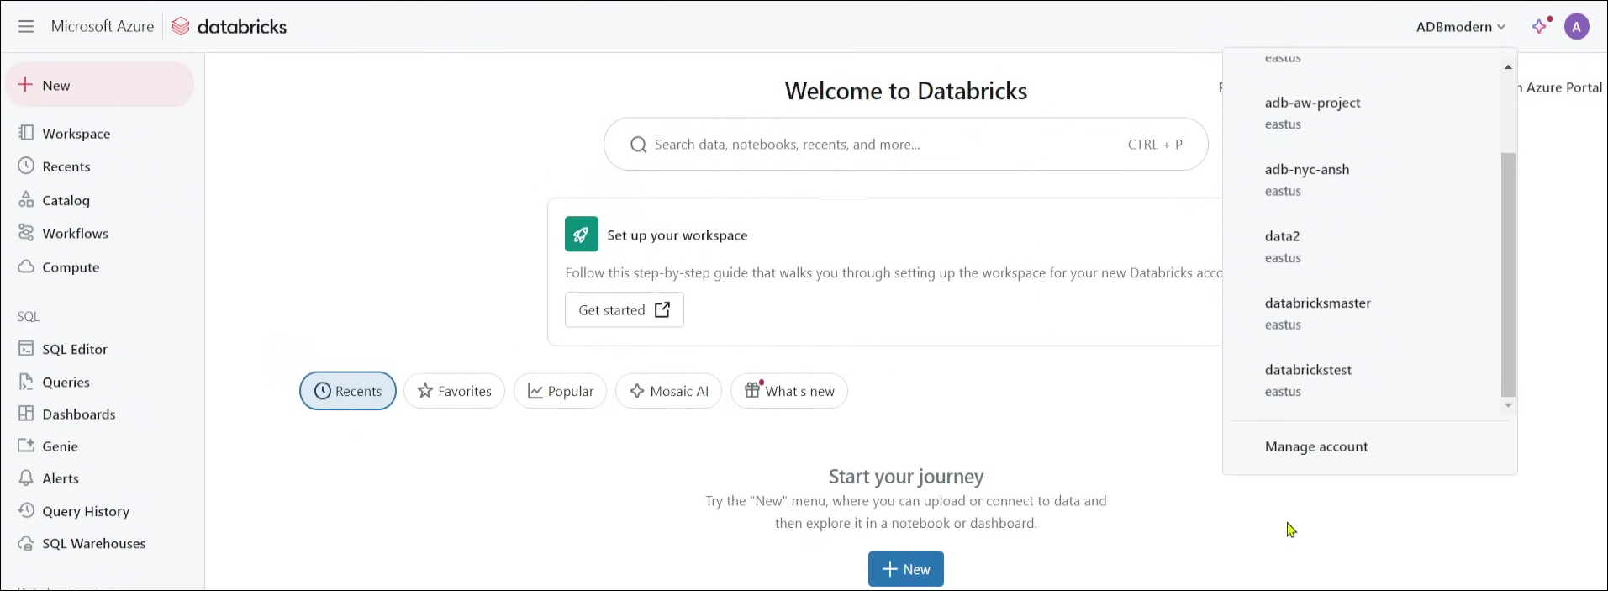

If you don’t see the managed account.
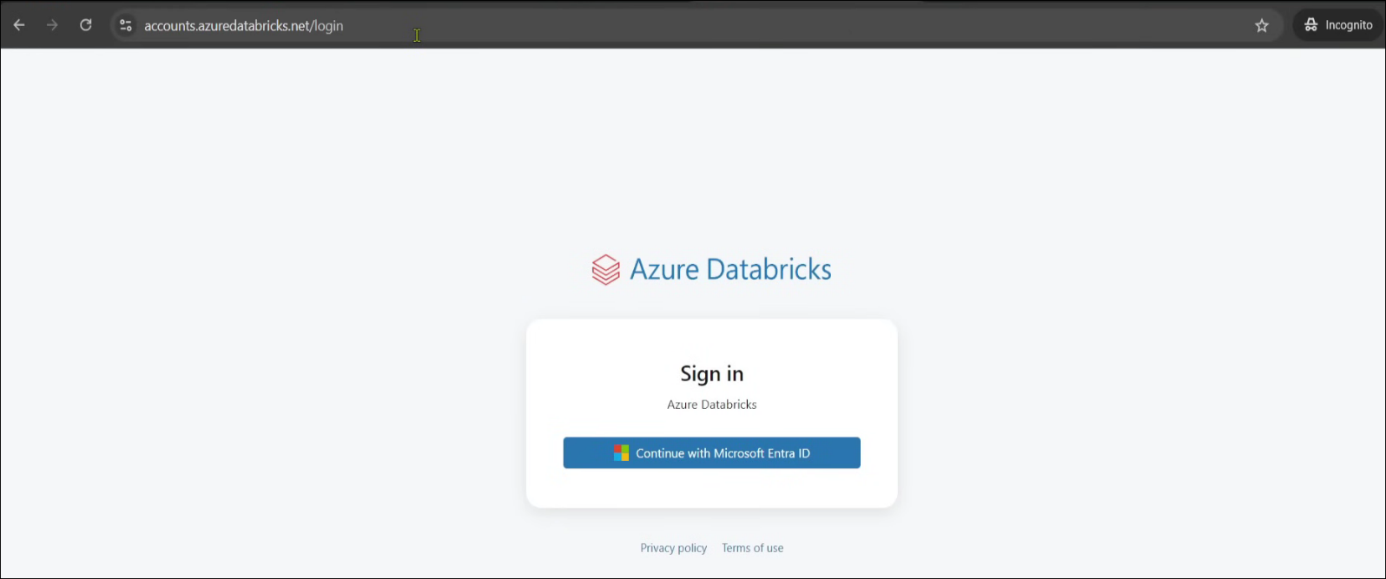
Go to accounts.azuredatabricks.net

Go to Microsoft Entra ID-under Manged user account -select user select user principal name for login
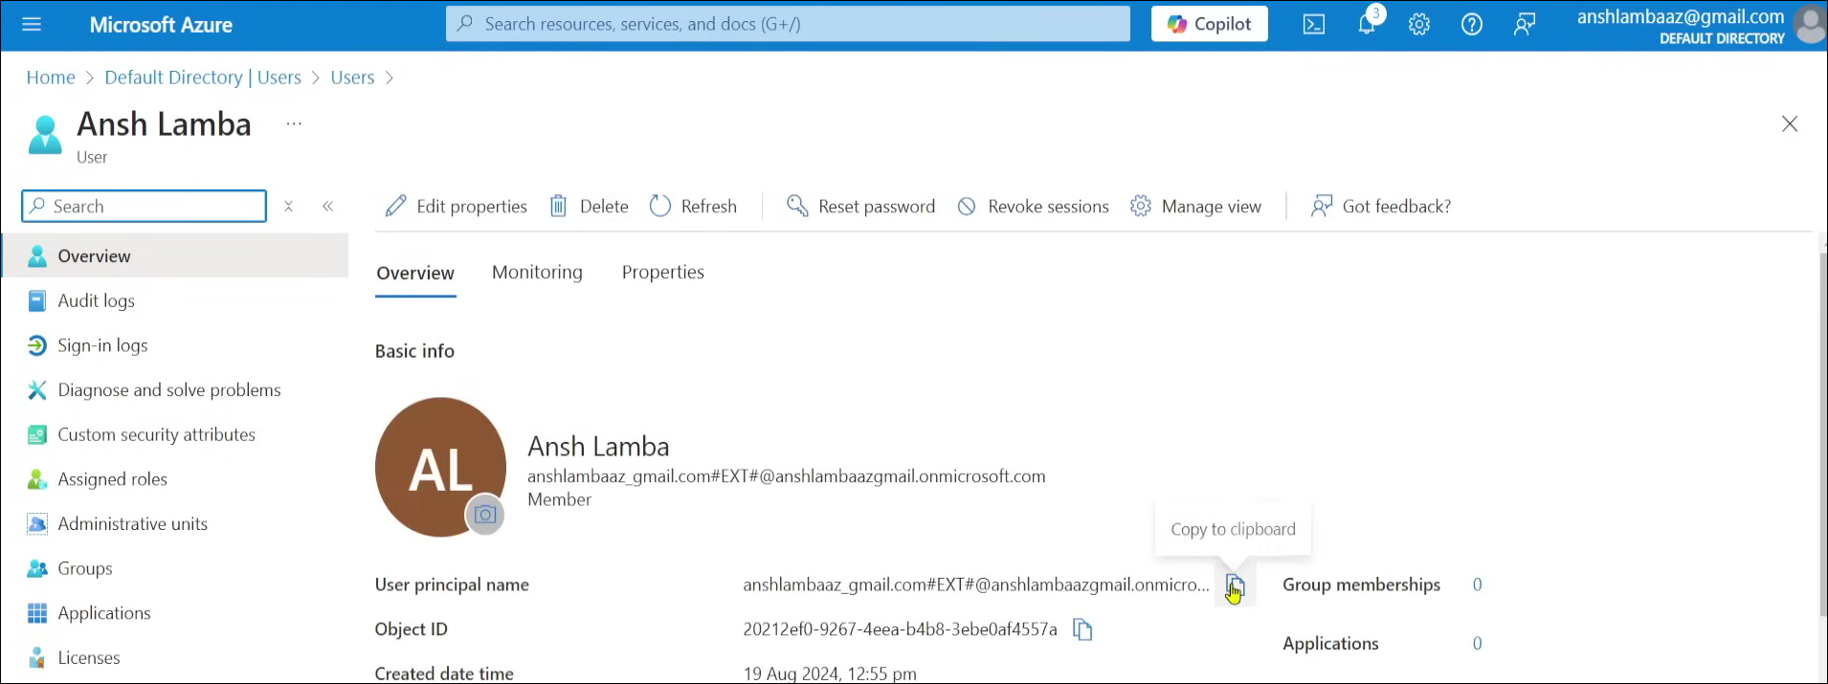

Once you click on Managed Account tab here is the home screen
This is admin console page
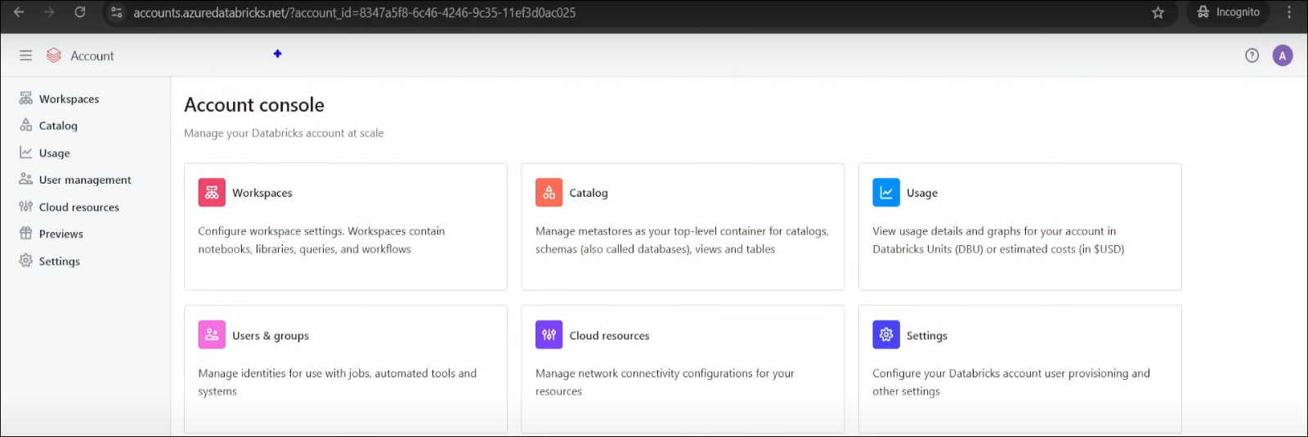
Create a metastore:
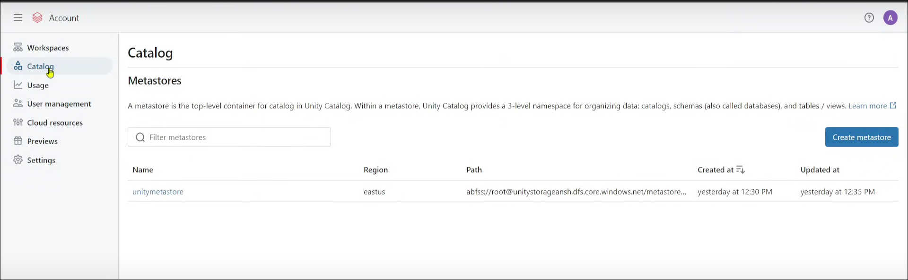

Here are the details you need to give after clicking create meta store

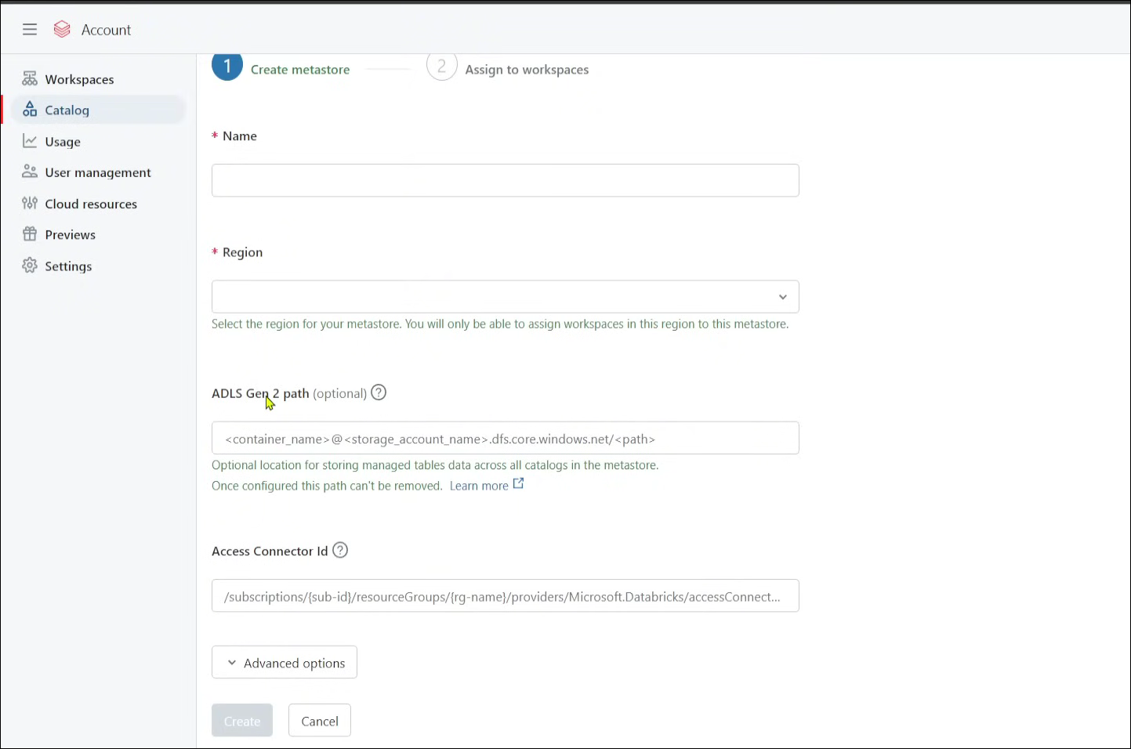

The ADLS Gen2 path refers to a location in Azure Data Lake Storage Gen2 where managed table data for the metastore will be stored.
- This is an optional field while creating a Unity Catalog metastore in Databricks.
- Once configured, this path cannot be changed or removed.
The expected format is: <container_name>@<storage_account_name>.dfs.core.windows.net/<path>

You must ensure the Access Connector ID (seen just below this parameter) has sufficient permissions (Storage Blob Data Contributor) to access this ADLS Gen2 path.

This setup is used in multi-workspace environments to centralize and secure data access across different Databricks workspaces using Unity Catalog.

Managed and External Delta Table

Managed table: When you create a manage table the metadata is stored in the metastore and the actual data stored in the default location of the cloud storage which is same as provided in metastore. When you drop the table by running drop command, it will delete both metadata and data in the cloud, as its both managed by metastore not by us.

External table: When you create a External table the metadata is stored in metastore and the actual data stored in the cloud storage defined by us. When you drop the table by running drop command, it will only delete metadata not the table data present in cloud, because the table data is managed by us not by metastore

Here is the default storage account and access connector through which it interact with storage account.
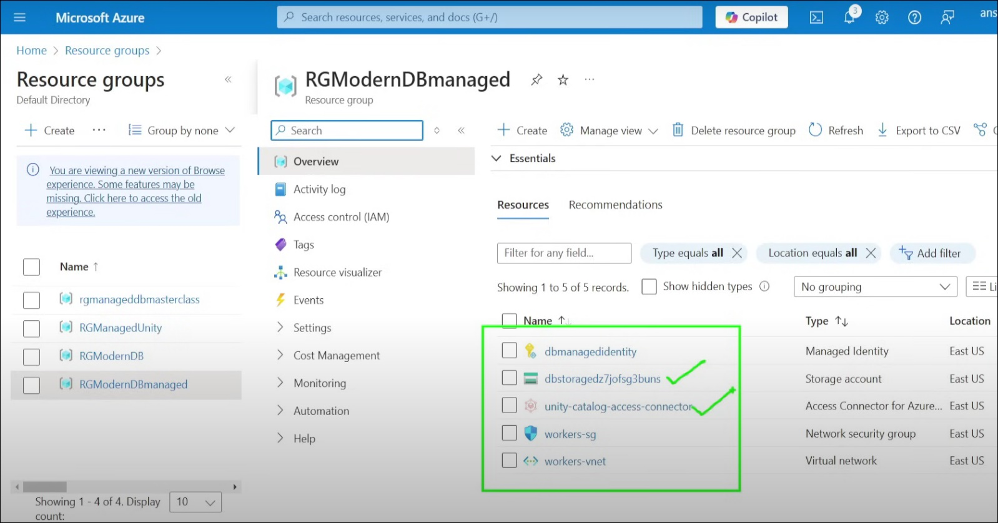
Does unity catalog metastore access the managed resource in created by databricks for default location? If I don't give Location in ADLS gen2 location in metastore unity catalog which is optional.

No, if you do not specify an ADLS Gen2 location in the Unity Catalog metastore, Unity Catalog does not automatically use or access the default Databricks-managed storage (i.e., the DBFS root like /user/hive/warehouse) for managed tables.

Unity Catalog vs. Hive Metastore (legacy behavior)
- In the legacy Hive metastore, Databricks automatically used the DBFS path:
/user/hive/warehouse
as the default location for managed tables.
- In Unity Catalog, however:
  - Managed tables require an external location (like ADLS Gen2).
  - Unity Catalog enforces storage isolation and governance, so it does not fall back to DBFS or any default Databricks-managed location.

What Happens If You Don’t Set a Metastore Location?
If no location is set at:
- Metastore level
- Catalog level
- Schema level
Then trying to create a managed table without an explicit LOCATION clause will result in an error: “AnalysisException: No managed location is configured for the schema.”

Then What You Should Do?

- Set a managed location at the Metastore level when creating the Unity Catalog metastore (recommended for simple setups).
- Define a MANAGED LOCATION at the catalog level:
CREATE CATALOG my_catalog
MANAGED LOCATION 'abfss://container@storageaccount.dfs.core.windows.net/mycatalog/';
- Define a MANAGED LOCATION at the schema level:
CREATE SCHEMA my_catalog.my_schema
MANAGED LOCATION 'abfss://container@storageaccount.dfs.core.windows.net/mycatalog/my_schema/';

Creating Root container for the Metastore and External container:

Metastore root contianer
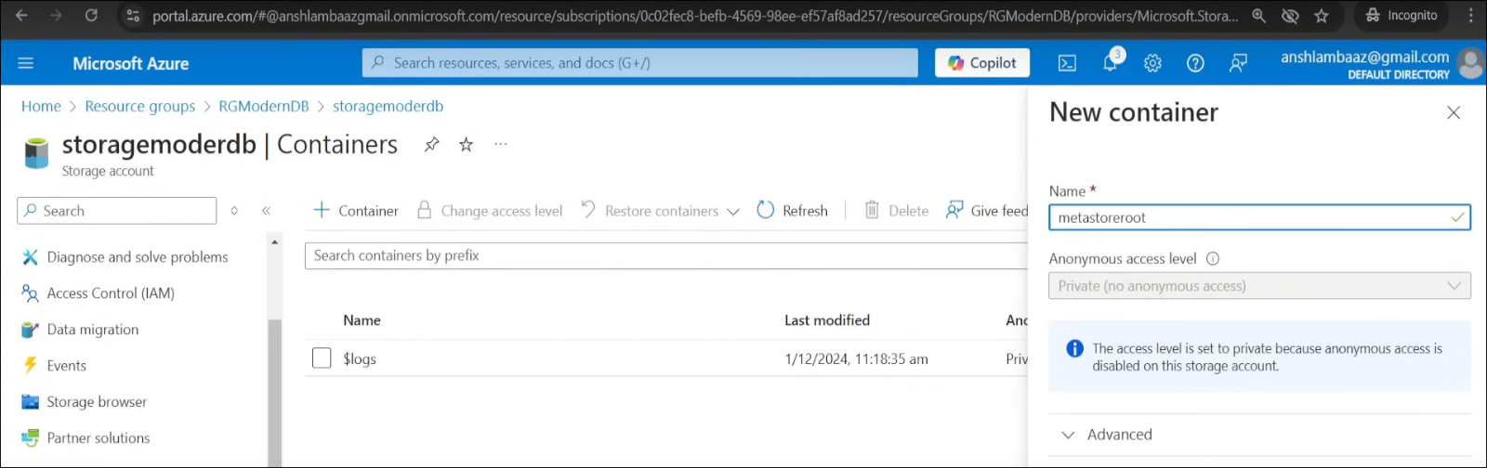
External container managed by me
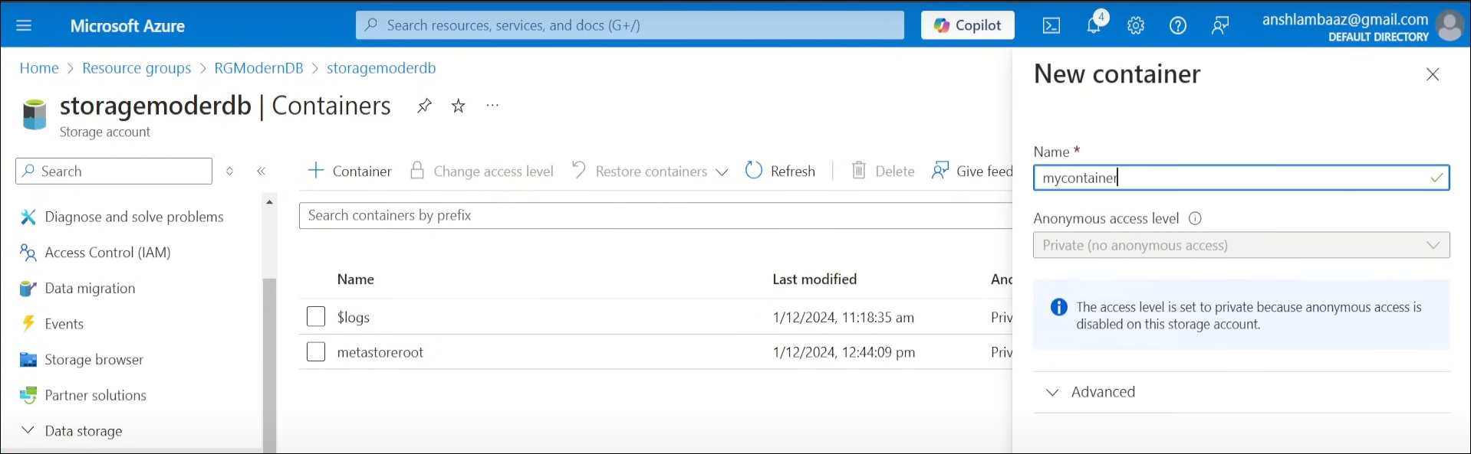

Creating Access connector:

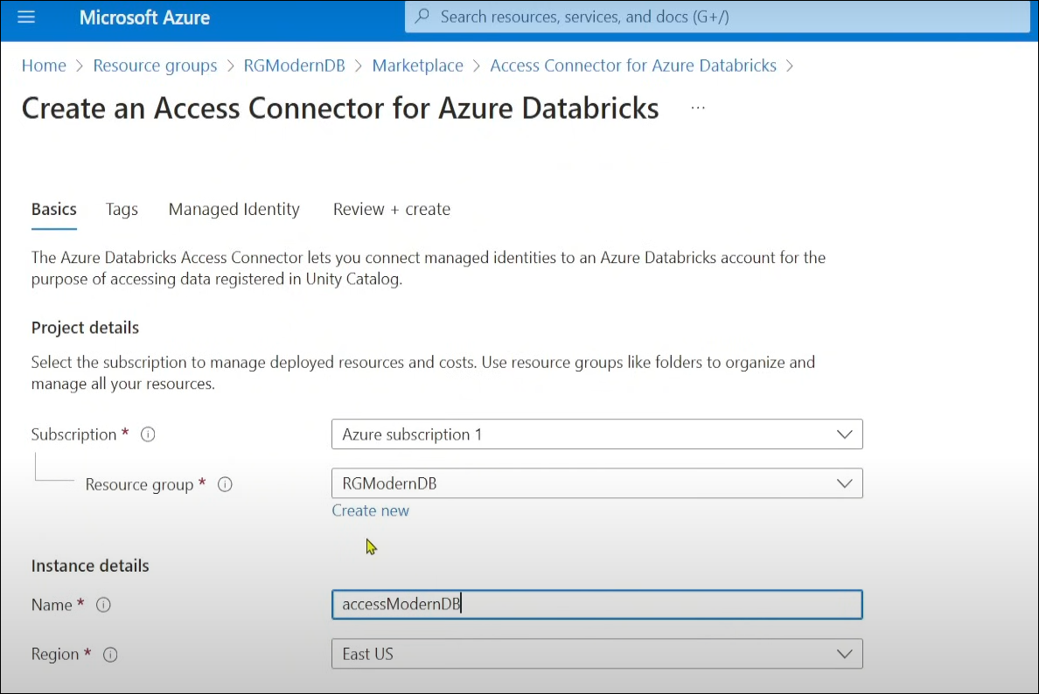
Databricks uses access connector to connect to ADLS Gen2. Does in order to get the write permission for access connector to access ADLS Gen2

The click on storage account---> access control---> add role assignment
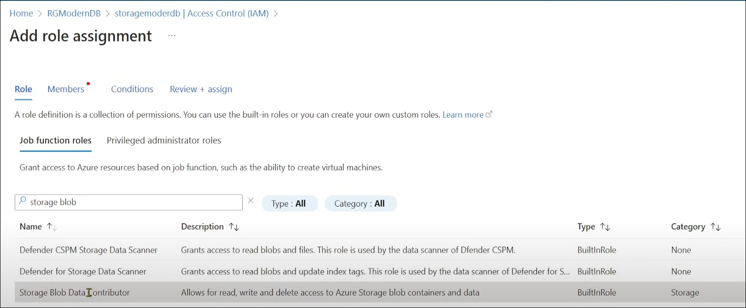

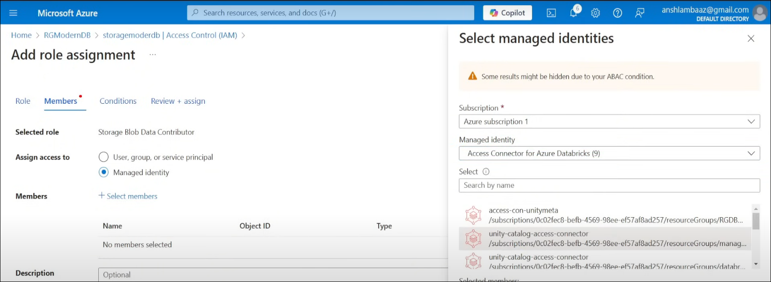

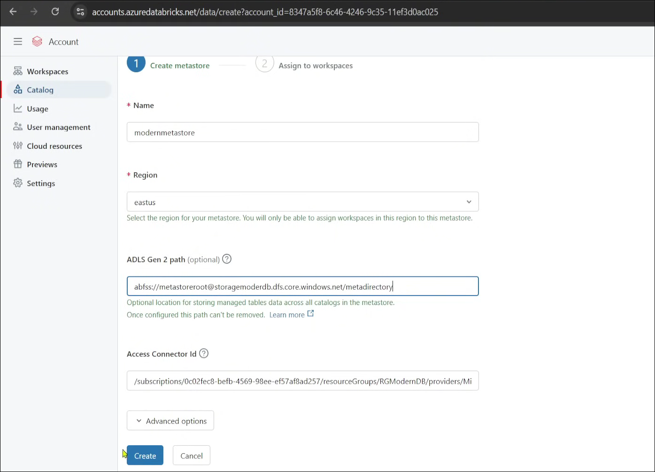
Now add these details in metastore Creation

In order to Create Multiple Catalog we need to Connect databricks workspace with unity metastore to Enable unity catalog. Thus Assigning unity metastore to databricks workspace
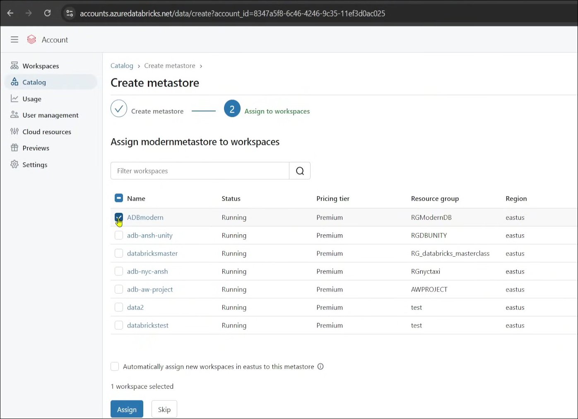

Enable it.
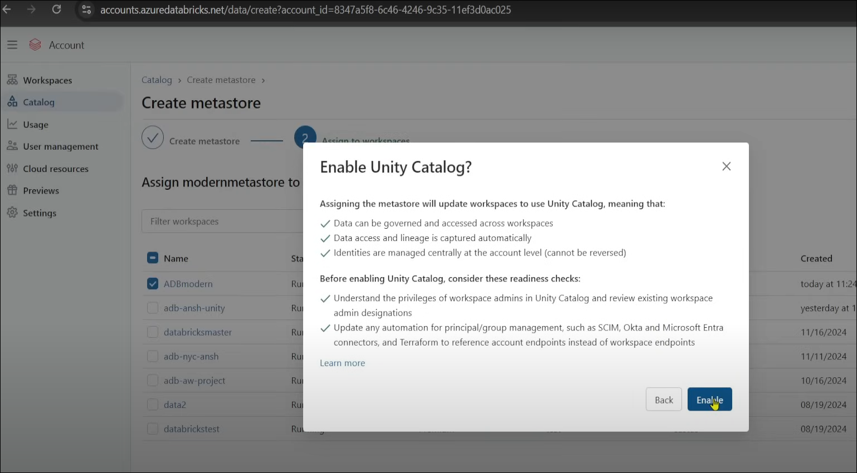
Now we have unable Unity catalog that we can further create new catalog.

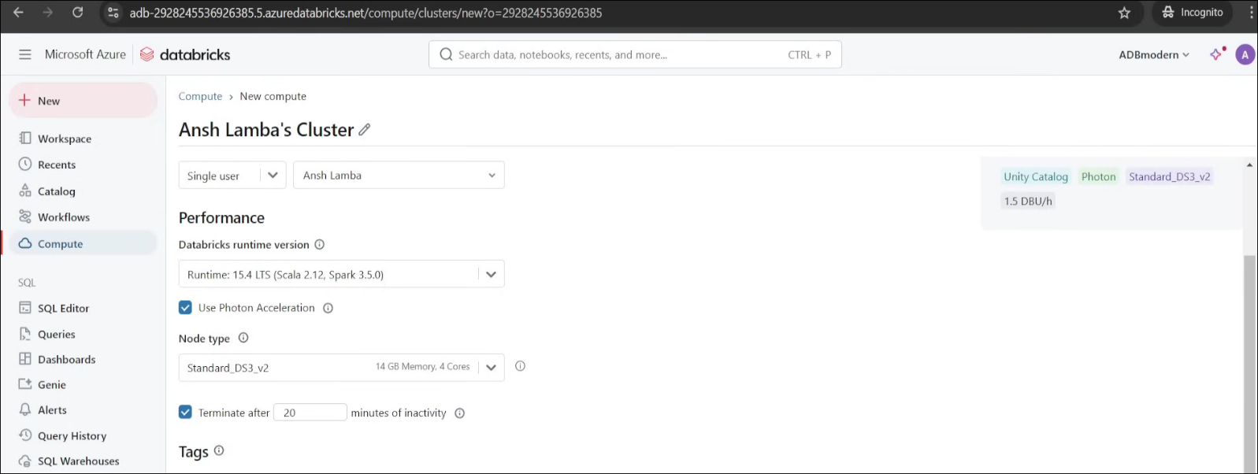
Create Compute in Databricks:
Since Unity Metastore is connected with databricks, does under compute section of databricks it showing Unity catalog enabled.

After Creating Cluster if we checked the Managed Resource grouped by databricks then, we see the virtual machine, harddisk and their Ip address
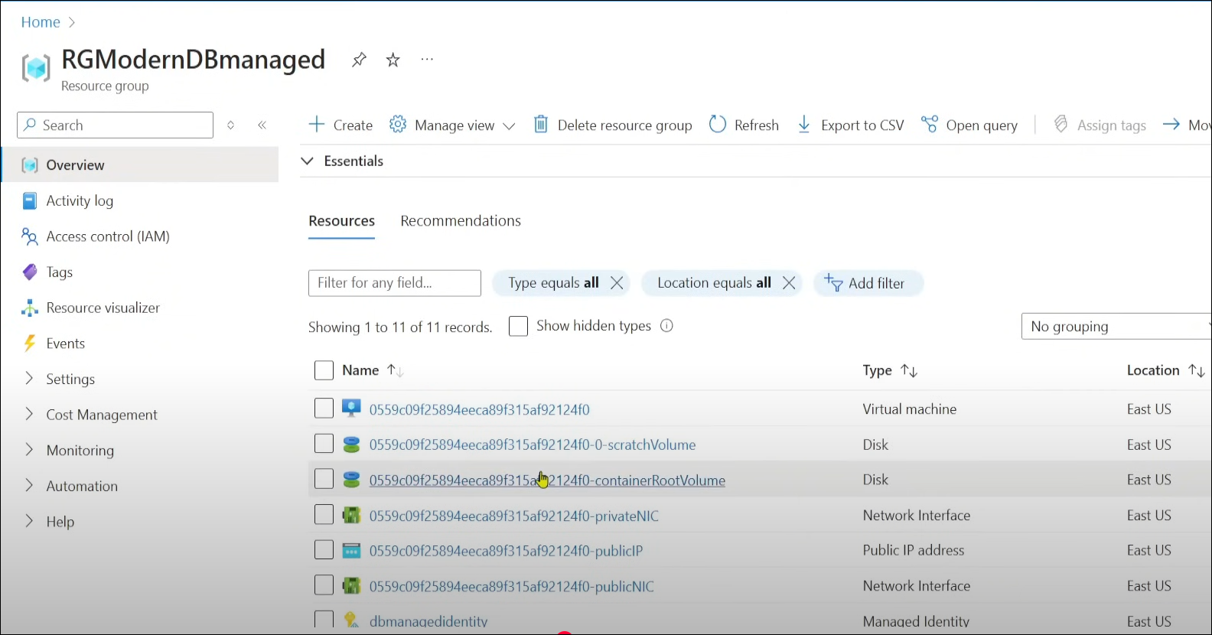

Databricks Catalog section:
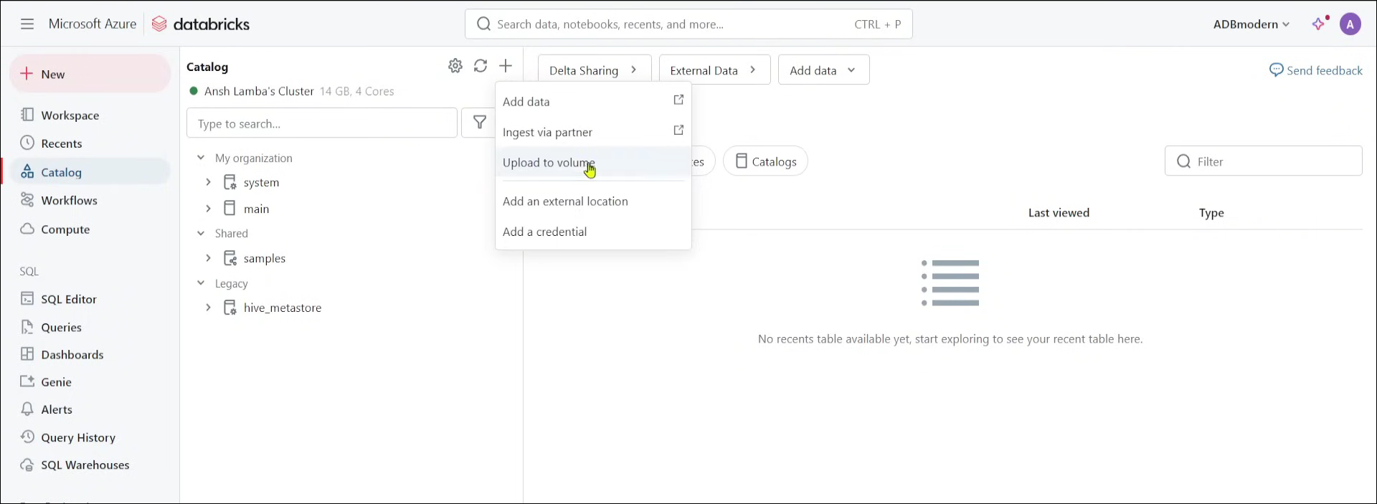

In order to create or see the add option in catalog we need to make the account as admin
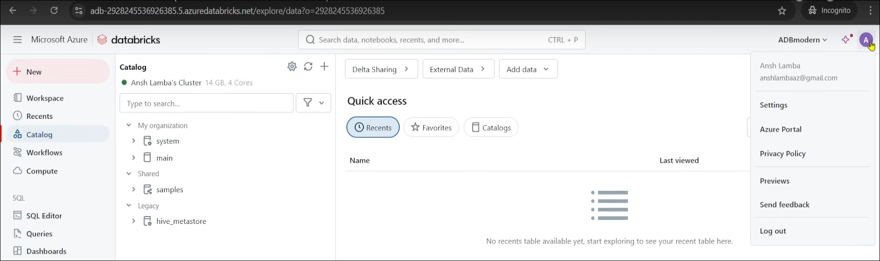

Here is the way to get admin access of above account
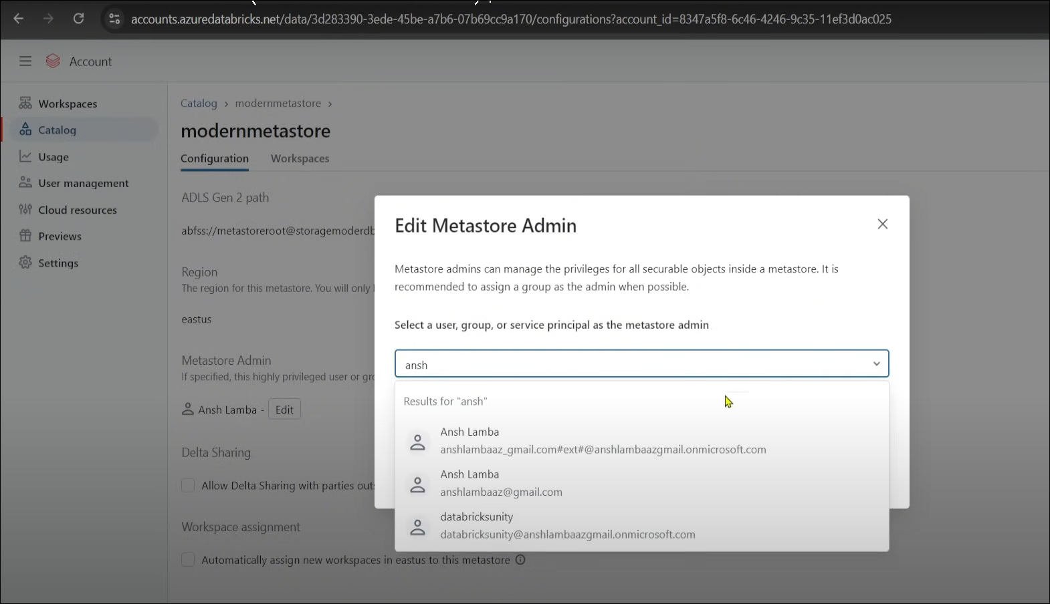
Create folder within workspace:
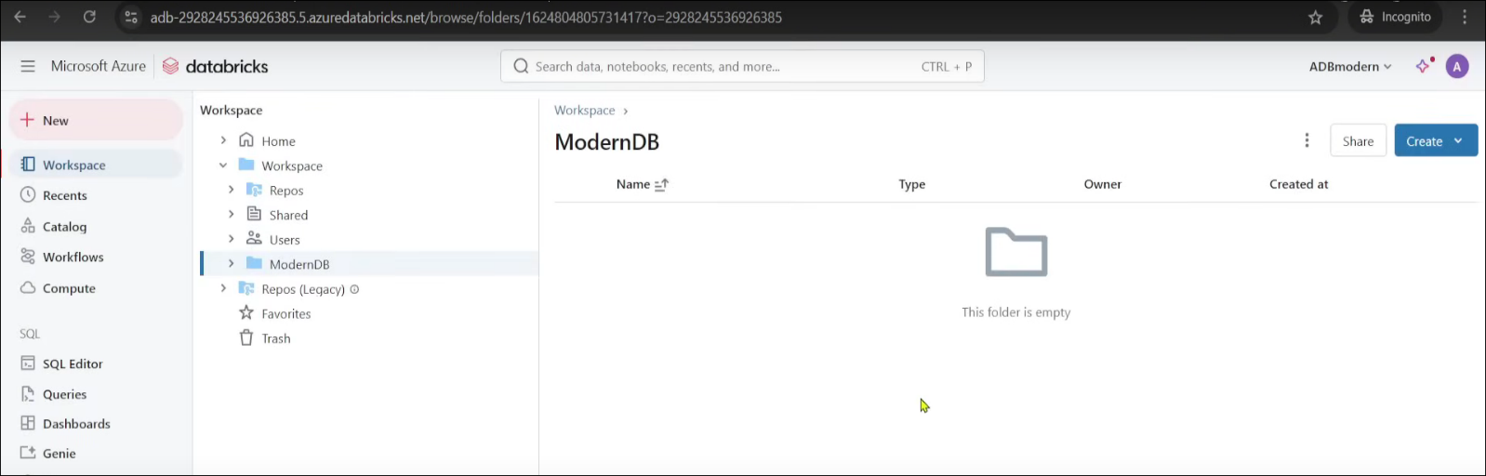
Thus create a notebook within that:
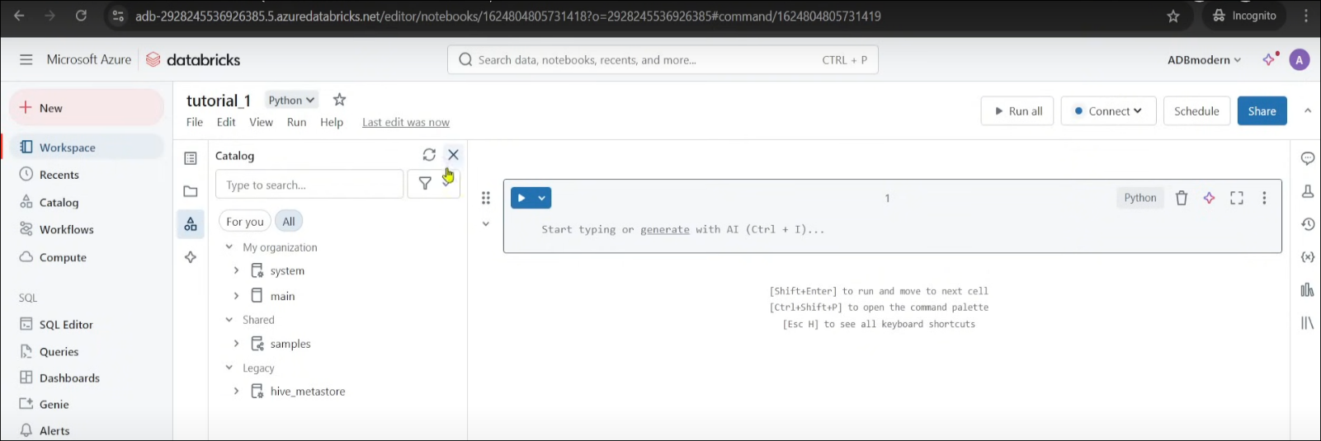
These are the languages used in databricks
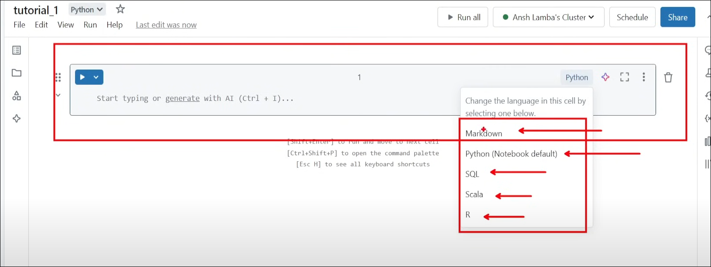

Let me show you the magic commands:
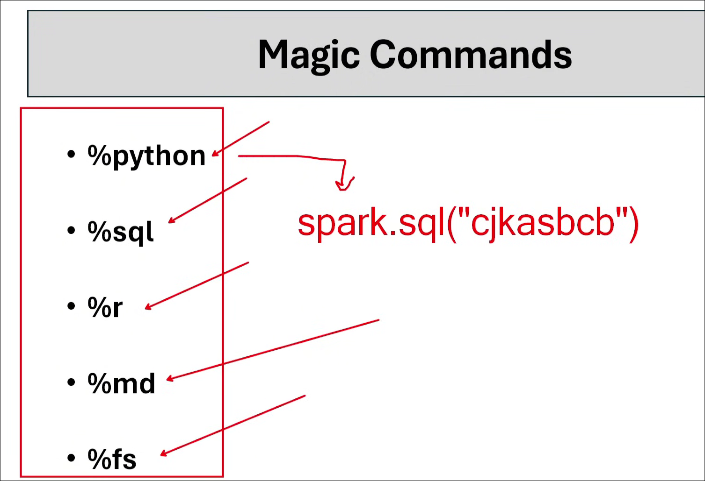

Accessing data in ADLS using Databricks workspace:

Databricks workspace can access ADLS gen2 by using external location for Unity Catalog.
We cannot create external location without unity catalog.

We need to add this access connector to the external location and when it gets attached it's called storage credential, it's nothing but we are creating just ID in order to give it to external location.

Go to catalog click on external data
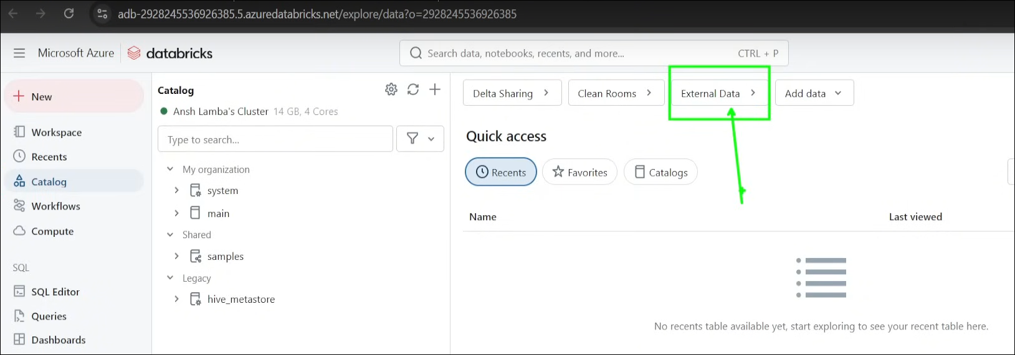

Create new storage credential:
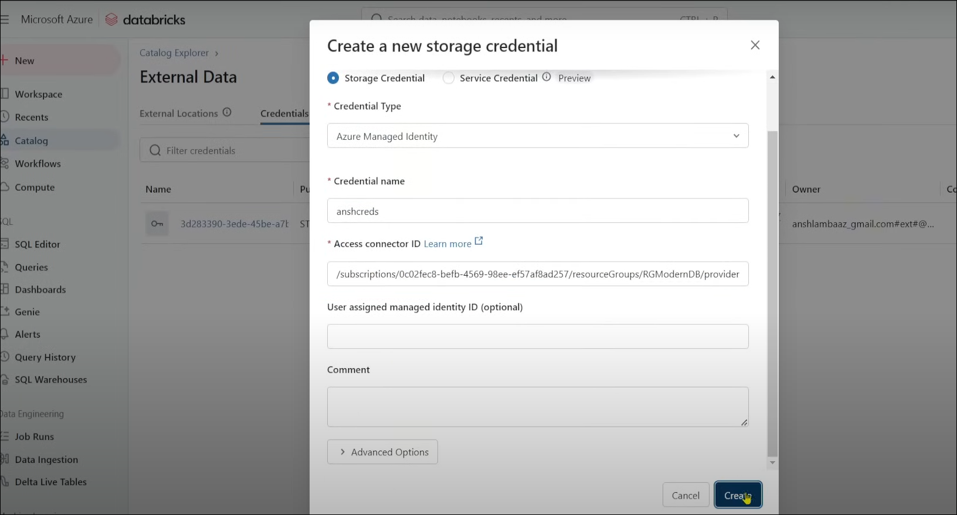

Thus we have created id

Now we have to create external location
Note: we create external location till container level that important tip

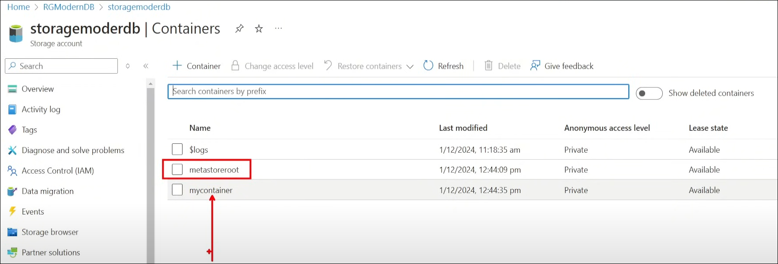

For metastoreroot container managed by metastore

For mycontainer this is our external data location. I will create external location based on my container
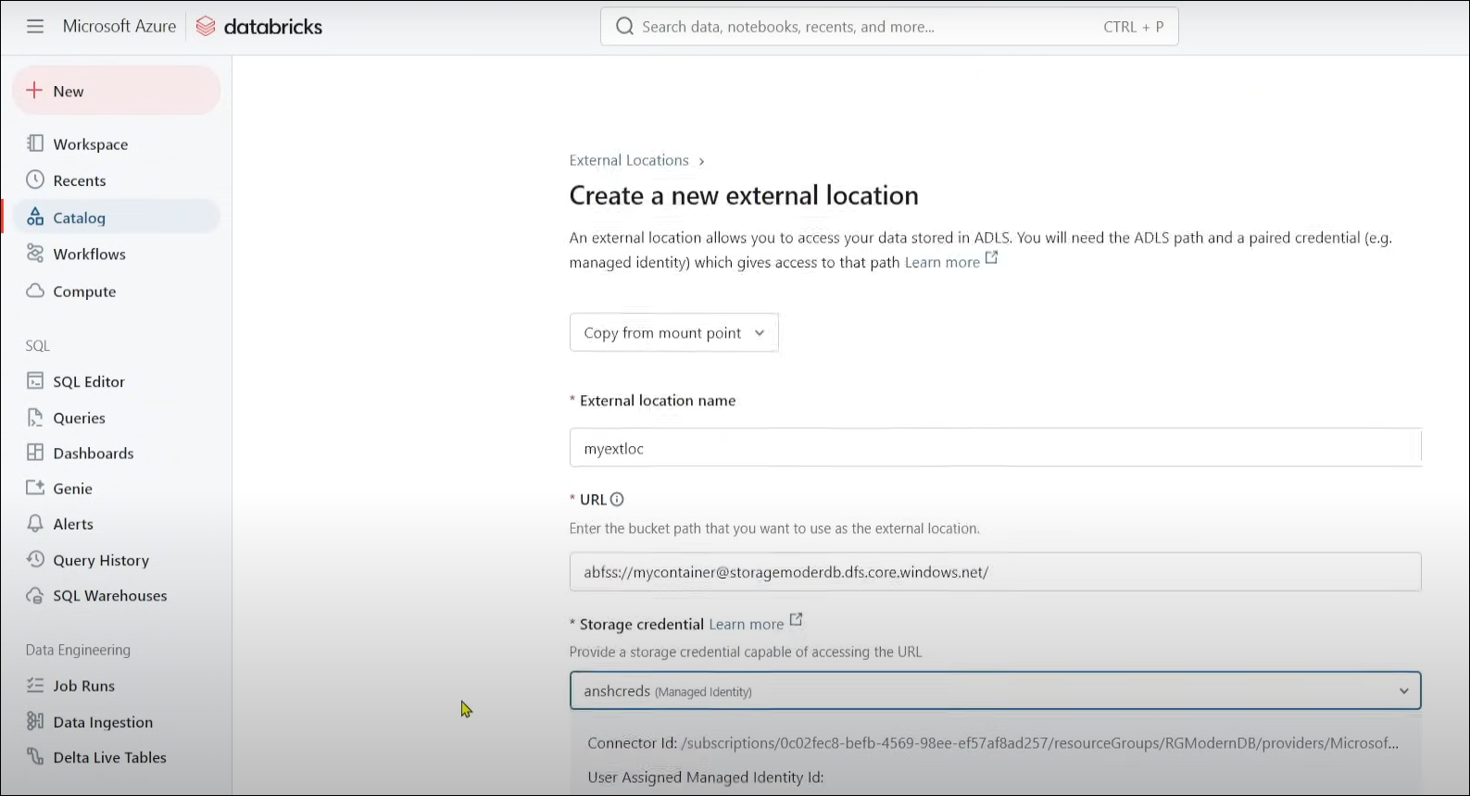

In my databrics notebook, if I want to read write data within that container i can do that why, because no I have external location created in my metastore and that metastore is linked to my databricks.

Tutorial- Notebok
Scenario-1
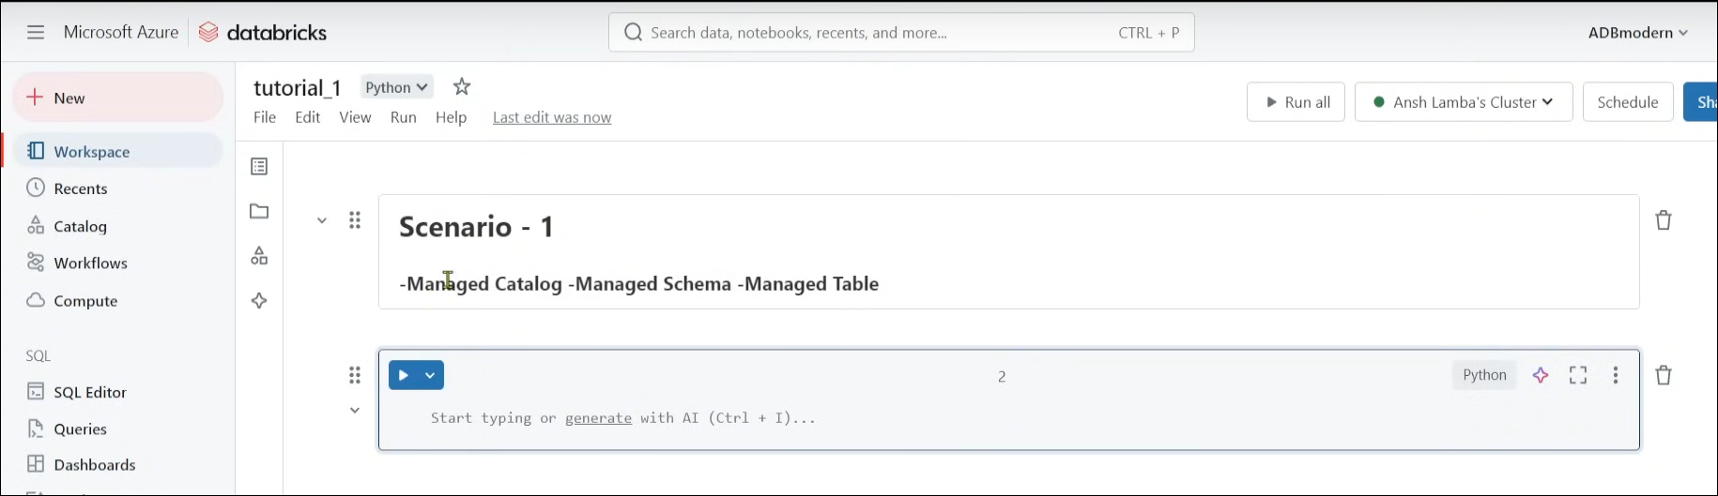

If you don't give path to managed catalog, schema, table it will take the default location present metastore

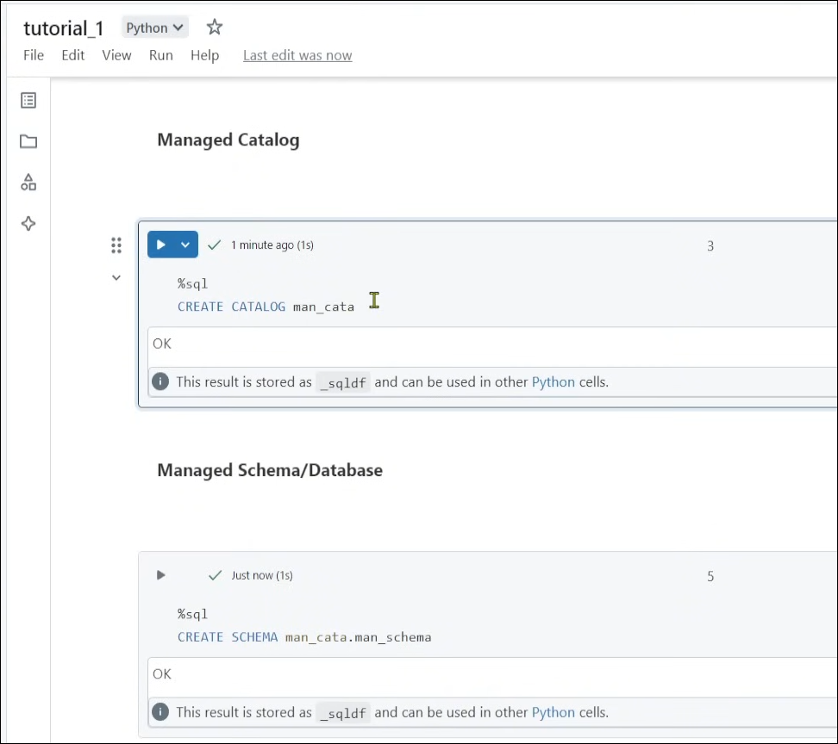

This is for managed table.
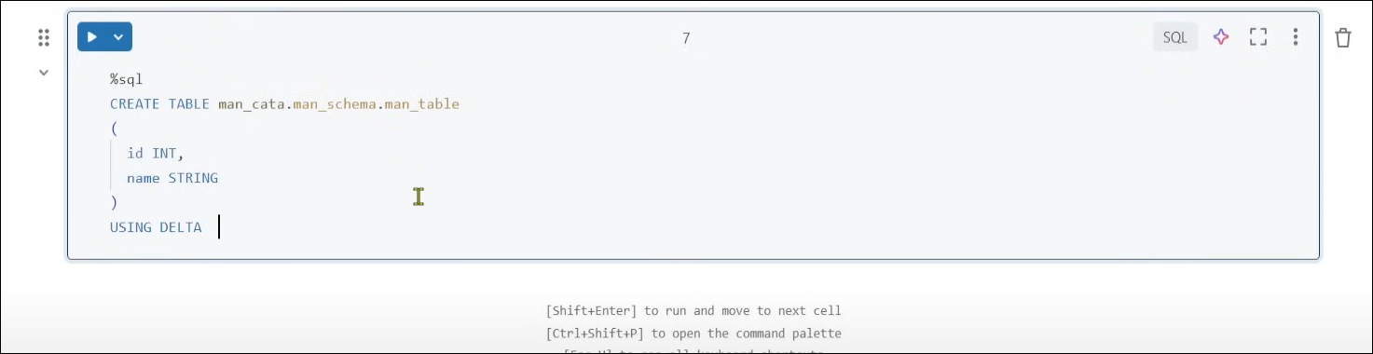

After that we can check the metastore container
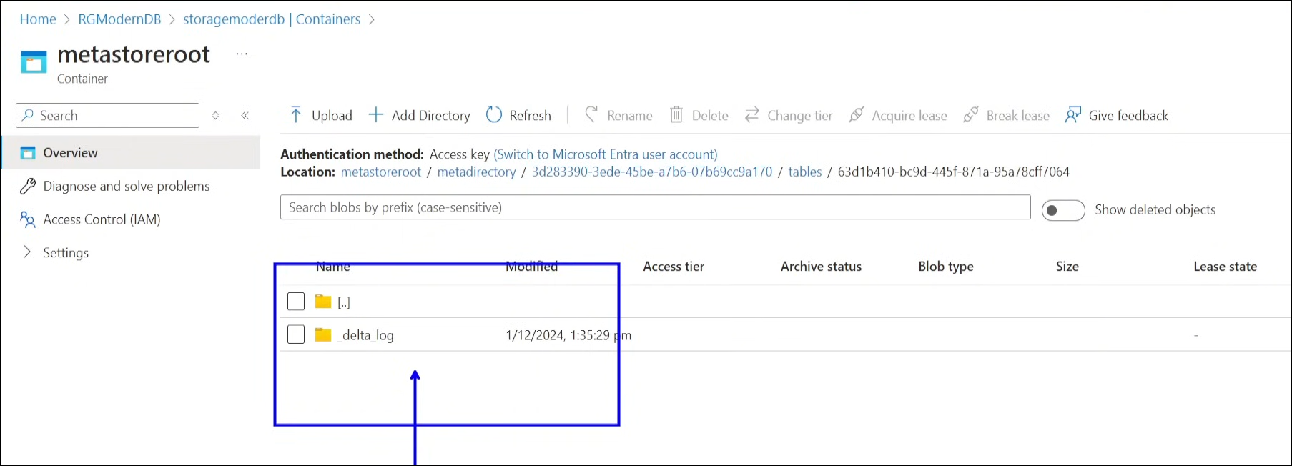

Scenario 2
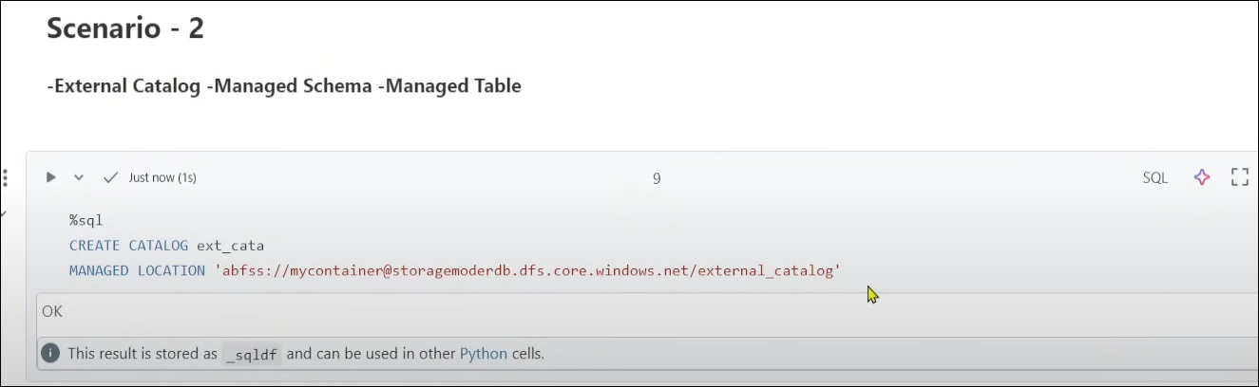

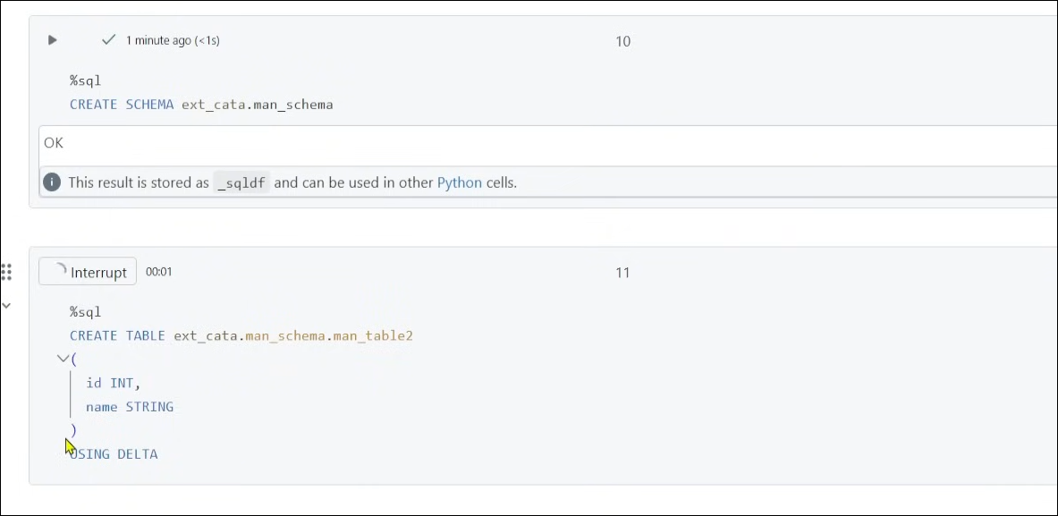

We can check azure storage cloud
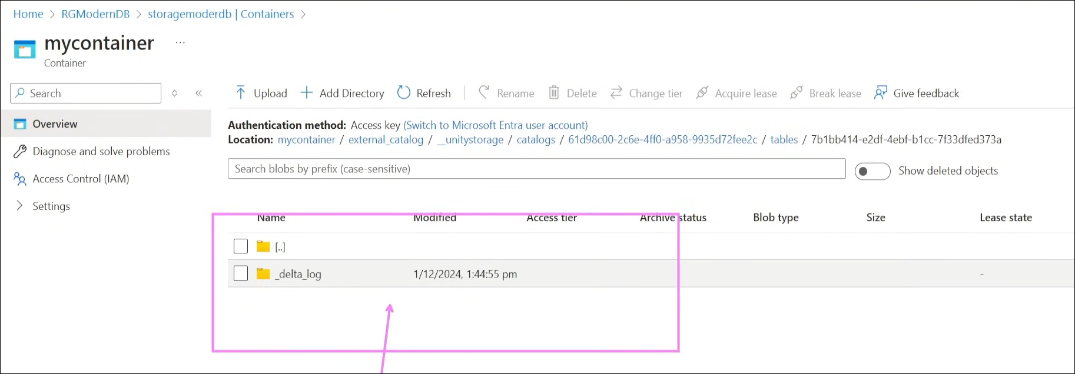

Scenario 3
External Catalog – External Schema – Managed Table

Within one external catalog we can create multiple schema does we are using existing external catalog to create external schema.
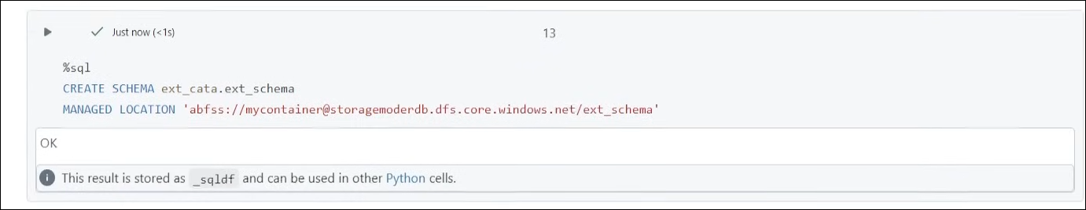

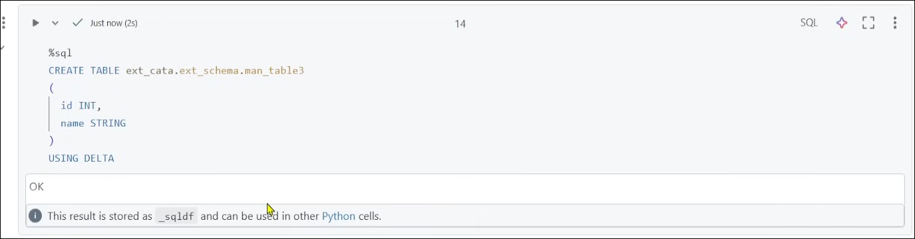

Here is the location where table is created:
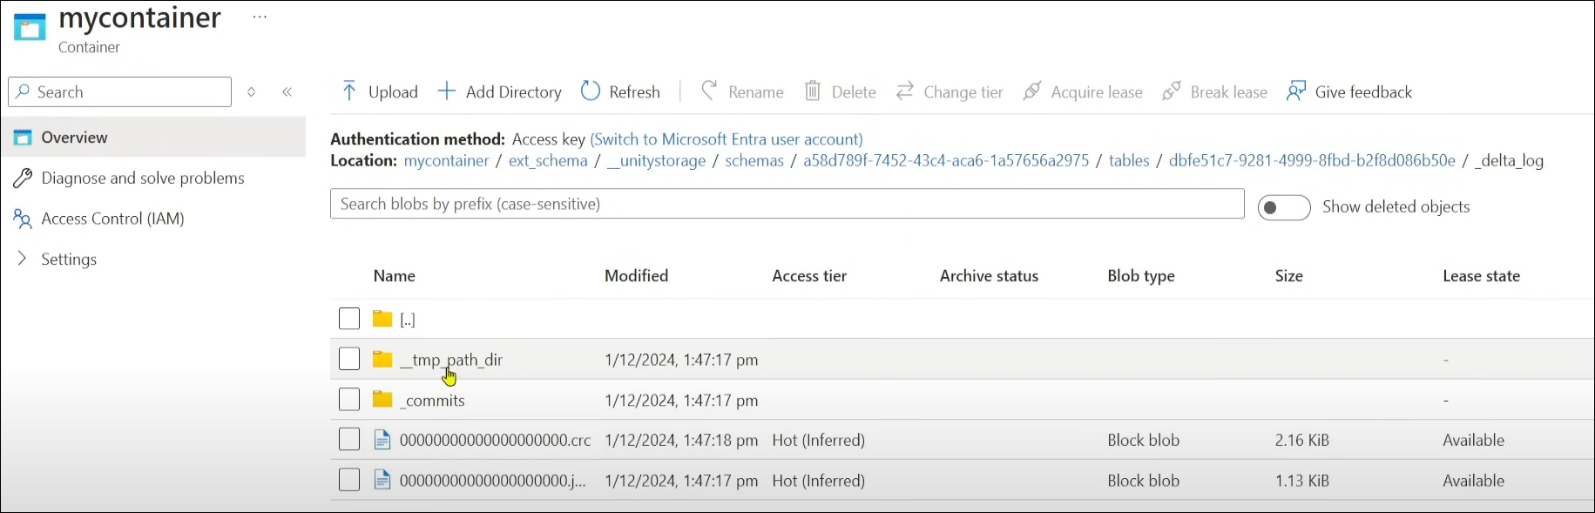

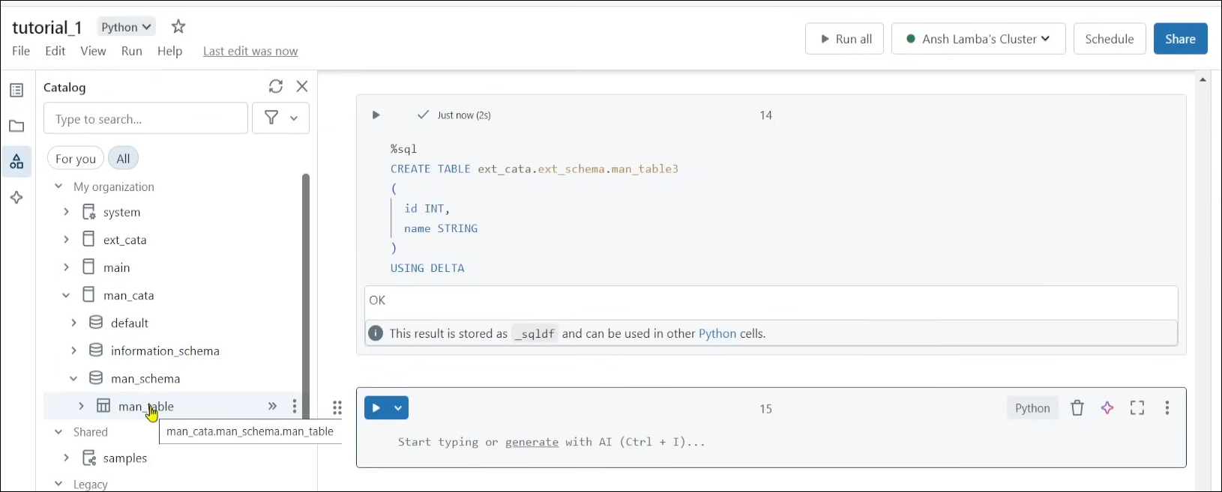
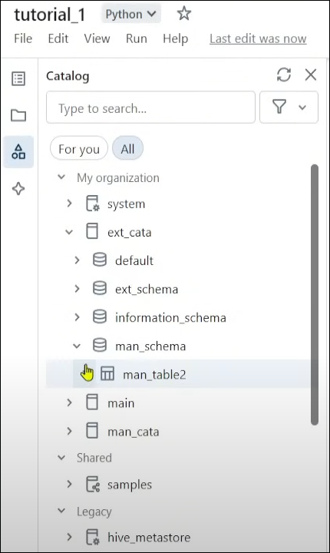
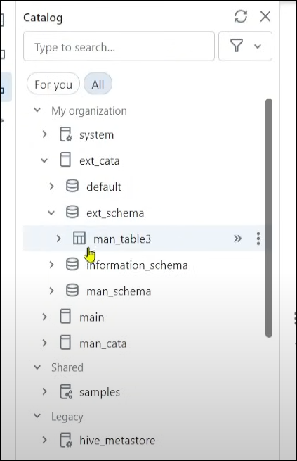

Scenario 4: External table
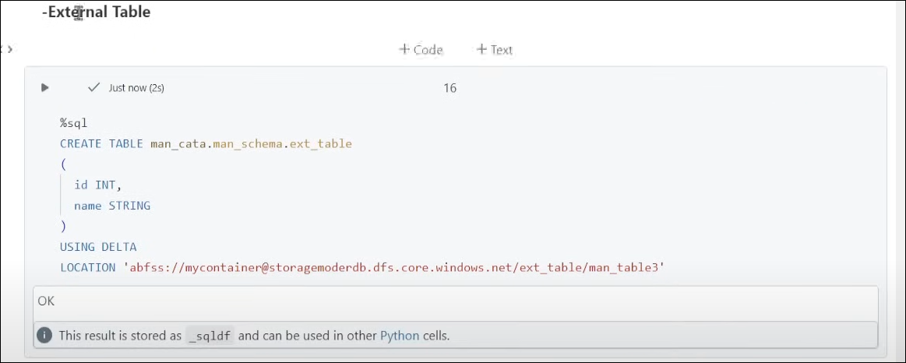

Here is the external table location
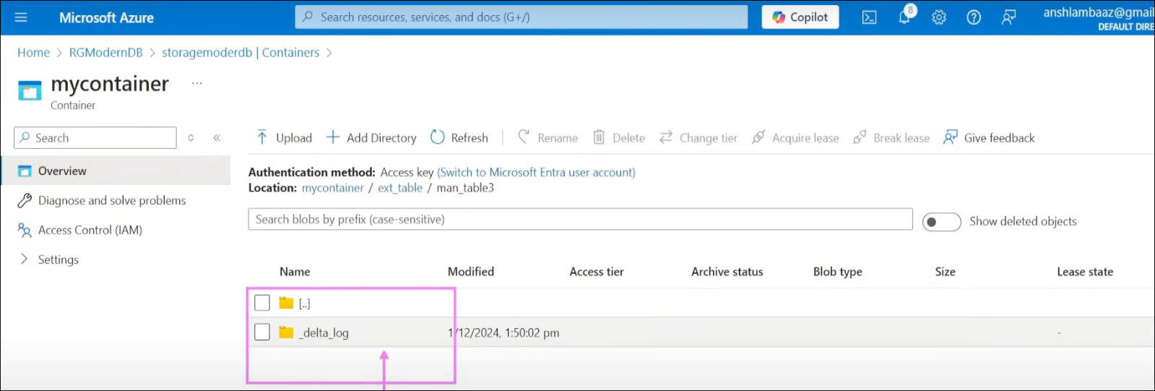
Here it the managed schema with external table
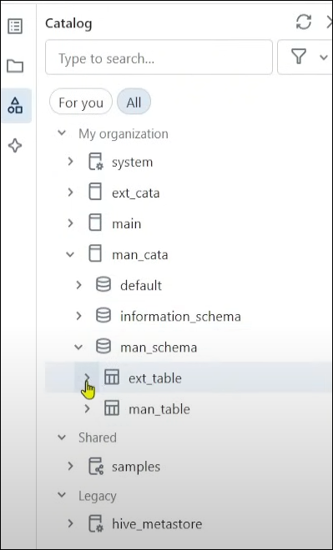

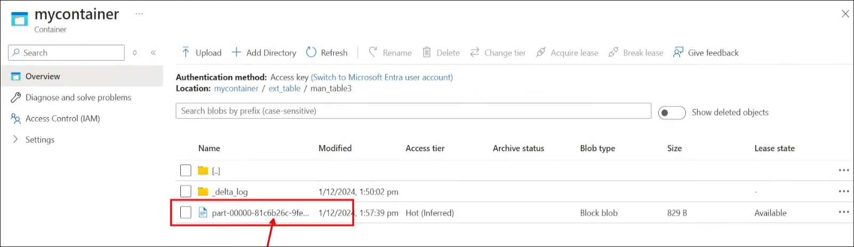
Droping Managed Table:
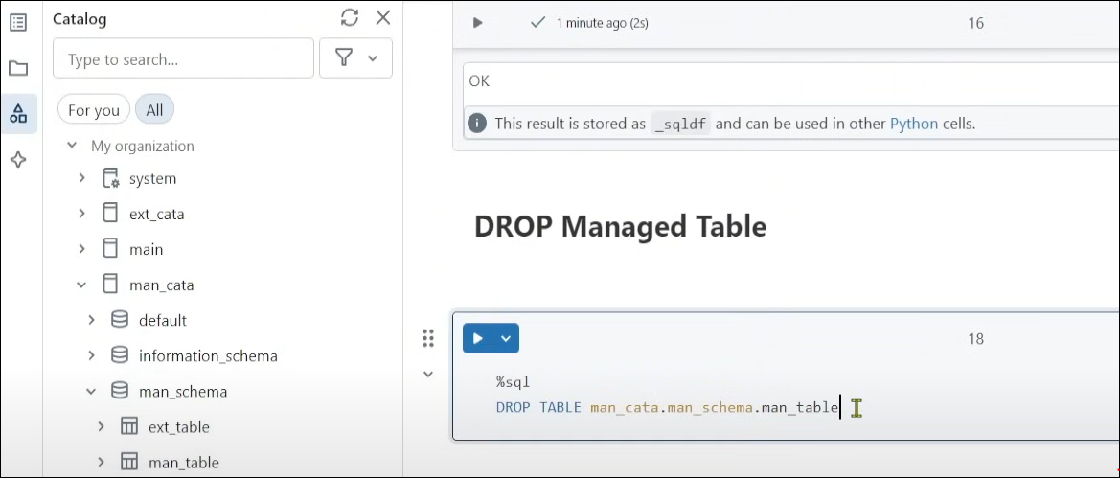

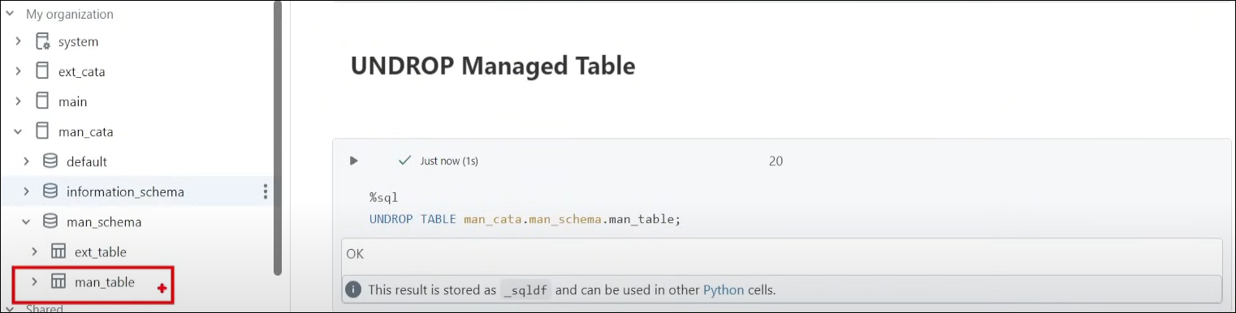
unity catalogue make sure that your data is deleted, when you are dropping managed table but after 7 days

If bymistake is deleted we can undropped the managed table.

Querying files using select:
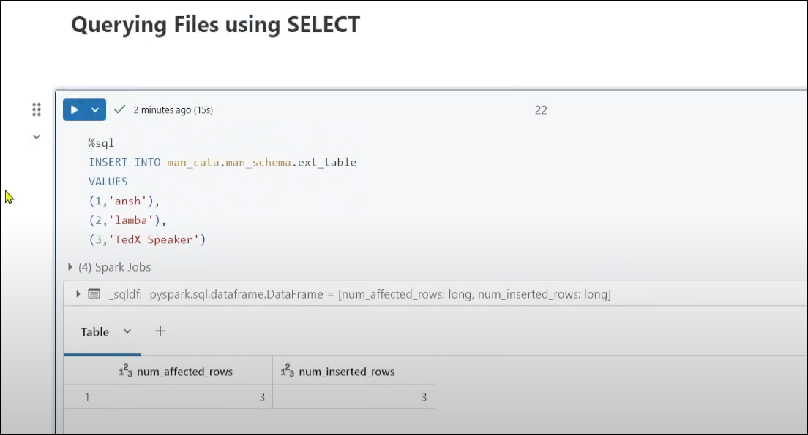

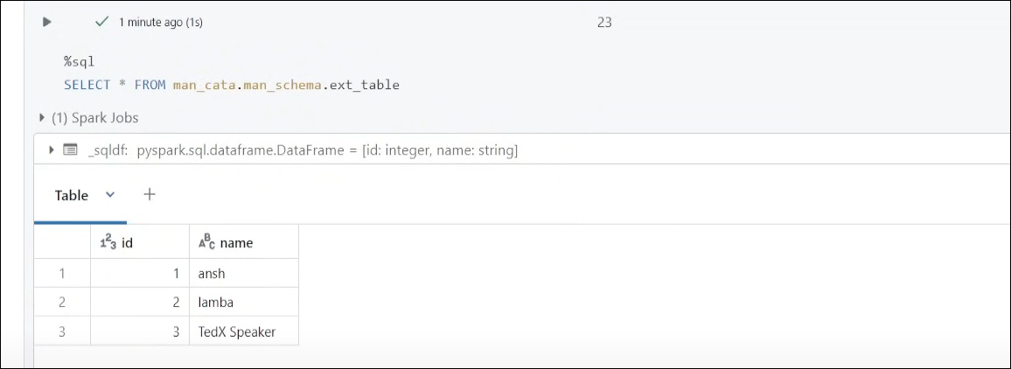

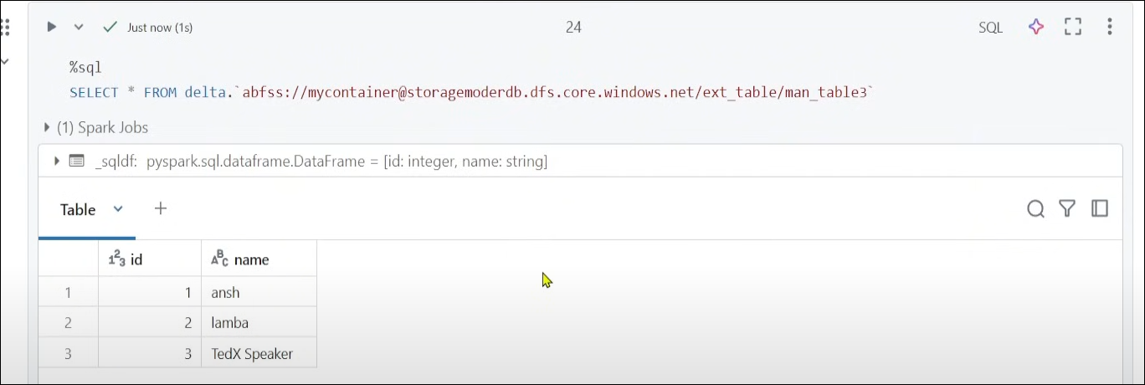
Even if you don't have any table or any view, you just want to directly query the database you can use code above for given location.

